Stiffness Equations For Structural Element
Geometric Nonlinearity

Table of Contents

1 Introduction 3
2 General equations for nonlinear strains and element stiffness 4
2.1 Nonlinear strains 4
2.2 Geometric nonlinear stiffness matrix 6
3 Plate equations 11
3.1 Displacements and strains 11
3.2 Preload stiffness 13
4 Planar beam equations 16
4.1 Displacements and strains 16
4.2 Linear stiffness matrix 17
4.3 Nonlinear Preload stiffness 21
4.4 Nonlinear large rotation stiffness 23
4.5 Total stiffness matrix 27
5 References 28
6 Appendix A: Integration of integrals in stiffness equations 29
6.1 Integrals for planar beam stiffness equations in section 4 30
6.1.1 Integrals for the planar beam linear stiffness, K_{L} , in equation 4.2.5 30
6.1.2 Integrals for the planar beam preload stiffness, 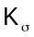, in equation 4.3.8 42
6.1.3 Integrals for the planar beam nonlinear large rotation stiffness, K_{R} 45

Introduction

This document shows the nonlinear equations that will be used in deriving element stiffness matrices for small strain, large rotation behavior of structures. Most of the work below is taken from references 1 and 2 and is summarized herein to clarify what will be used for such structural behavior.

The approach to the nonlinear problem is based on incrementing the applied loads and solving for the corresponding increments of displacement and element forces. As such, the element stiffness matrices are tangent stiffness matrices.

Section 2 begins with a general statement of the nonlinear Green’s strain displacement relationships and shows how these result in a nonlinear tangent stiffness matrix that can be written as the sum of 3 contributions: a linear stiffness matrix, a nonlinear stiffness matrix due to element rotation, and a nonlinear preload stiffness matrix .

In section 3, the nonlinear stiffness equations for a plate bending element are derived. Since plate elements have no closed form solution for displacements due to applied loads, these matrices have to be developed in terms of parametric coordinates and integrated numerically using Gauss quadrature.

Section 3 has the nonlinear stiffness equations for a planar beam element and is included to help clarify these nonlinear effects for an element whose matrices can be developed in closed form.

Appendix A is included to document the calculation of the integrals for stiffness terms for the beam equations of section 3

.

General equations for nonlinear strains and element stiffness

Nonlinear strains

Let u, v and w be the displacements in the x, y and z directions. Greens nonlinear strains are:

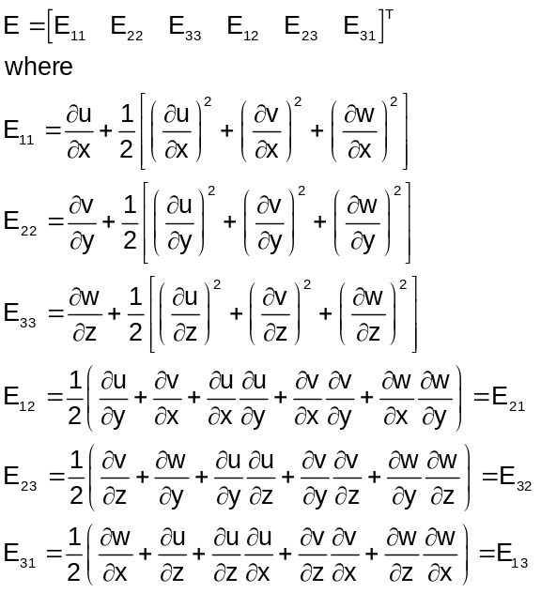

The terms involving products of partial derivatives are the nonlinear part of the strains (denoted as 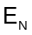) and the remainder (denoted as 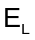) are the familiar linear strains that apply when the displacements are small. Thus:

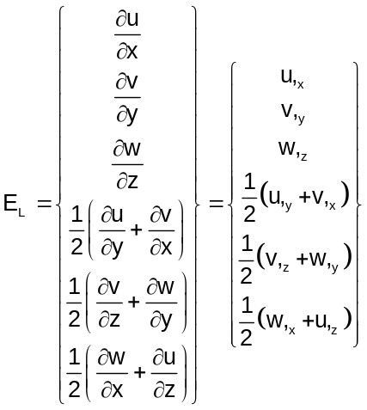

and
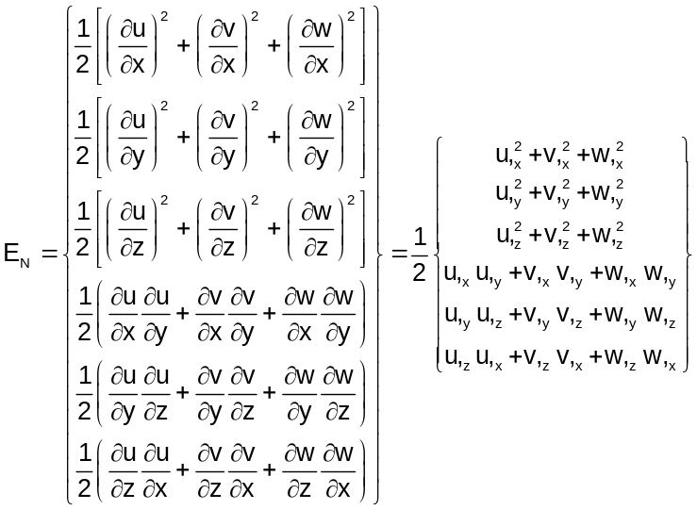

The comma indicates partial differentiation of u, v or w with respect to x, y or z

The nonlinear strains, E_{N} , are functions of the squares of derivatives of displacement components with respect to element coordinates and can be written as the product of a rectangular matrix, A, and a column vector, , as:

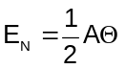

where

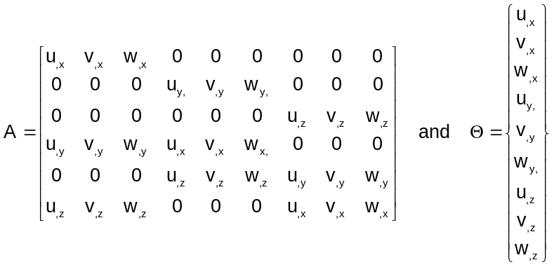

By an appropriate assumption for displacement variation within an element, changes in strains (dE) can be written in terms of a shape function matrix B times changes in displacements at the nodes of the element as:

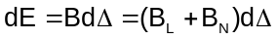

where B has been split into two parts (linear and nonlinear). 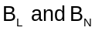 are matrices containing element appropriate shape functions (see below) and is a column vector of the displacements at the element nodes:

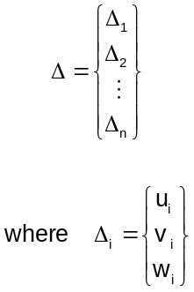

The linear strain-displacement matrix, 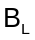, is constant and the nonlinear strain-displacement matrix, 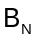, is a function of the element displacements. The forms for , will be different for each element type. For example, for plate elements consists of the 3 translations and the 2 in-plane rotations for each of the element nodes. Thus, for a quadrilateral element contains 5 terms for each of the 4 nodes. The matrices are generally formulated based on shape functions in terms of element parametric coordinates which are transformed to element physical geometry through the use of Jacobian matrices.

Geometric nonlinear stiffness matrix

Internal element forces, F, at the element nodes are determined through:

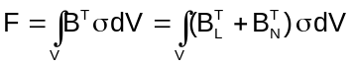
In nonlinear analyses, the applied forces will be incremented and the corresponding increments of displacement will be determined. Thus, the increment of element nodal forces will be:

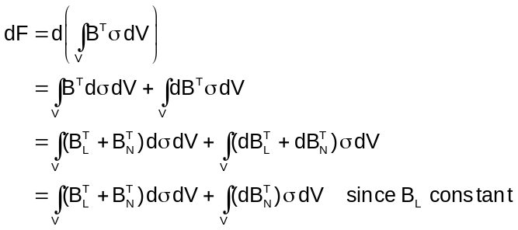

Element stresses are related to element strains through the constitutive matrix, D:

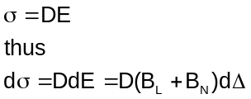

where 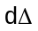is the increment of element displacements corresponding to the increment of applied loads. Substituting equation 2.2.3 into 2.2.2 and using 2.1.6 yields:

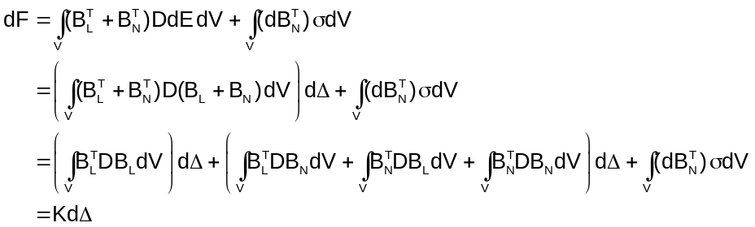

Where K is the element stiffness matrix including the effects of geometric nonlinearity and can be written as:

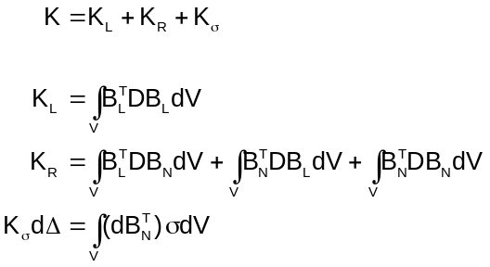

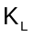is the normal stiffness matrix for an element with linear strains. 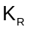is the contribution to element stiffness due to large rotations. is the contribution due to element “preload”. At each load increment in the analysis the element stresses are updated and a new is calculated.

can be developed in terms of element stresses as shown below. This will be done here for a 3D solid element that has displacements u, v and w as functions of element coordinates x, y and z and has the Green’s strain tensor given in equation 2.1.1. The general procedure will also apply to other elements and that will be made clear in each element discussion later.

The u, v and w displacements for an element are approximated by polynomials, N(x,y,z), times element nodal displacements (u_{i}, v_{i}, w_{i} for i=1,2,…,n where n=number of element nodes) as:

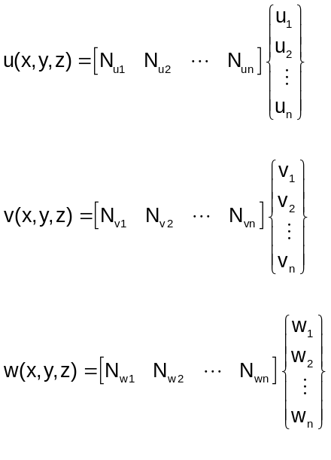

The N’s are functions of element geometry and differ for each element type. Using equations 2.1.7 and 2.2.6, in equation 2.1.5 can be written in terms of the N_{i} and _{i} as

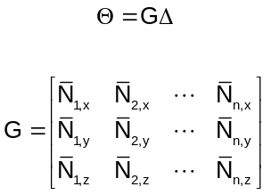

where

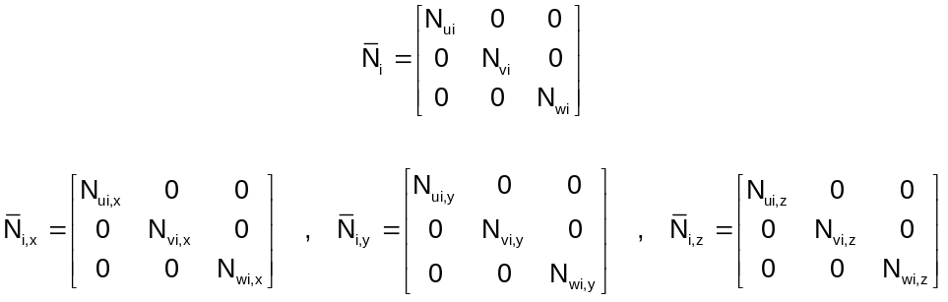

The matrix B_{N} relates increments of displacement to increments of nonlinear strain. Thus, from equation 2.1.6 for the nonlinear strain:

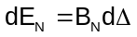

From equation 2.1.4:

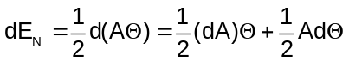

Due to the properties of A and , and using equation 2.2.7, plus the definition of in equation 2.1.5 this is:

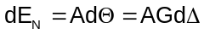

Comparing equations 2.2.9 and 2.2.11, the nonlinear strain-displacement matrix B_{N} is:

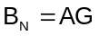

Since G is not a function of element displacements:

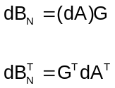

Substituting equation 2.2.13 into 2.2.5 the preload stiffness is:

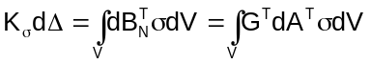

From equation 2.1.5:

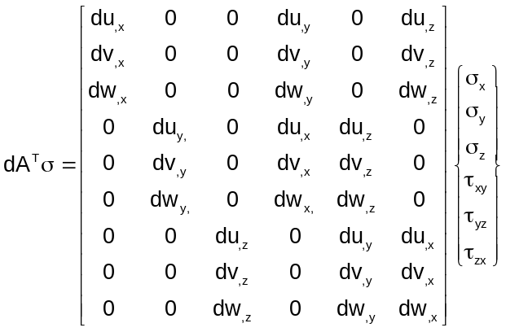

This can be rewritten as:

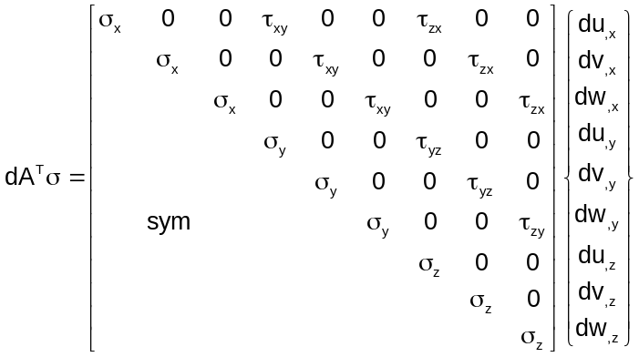

or:

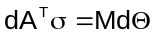

where
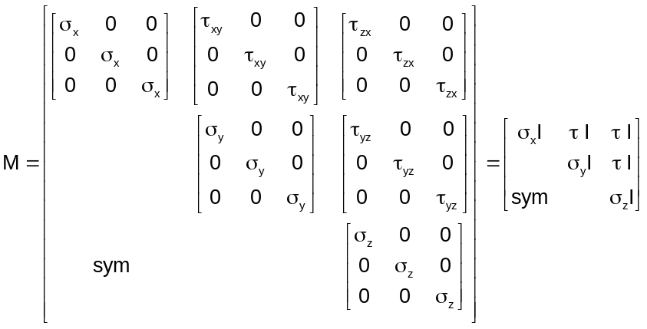

And I is the 3x3 identity matrix. Substituting 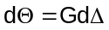 (based on equation 2.2.7) into 2.2.17 and the result into 2.2.14 we get:

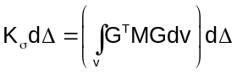

which requires the preload stiffness matrix to be:

This is the general form of the preload stiffness matrix which will be used for all elements. In what follows we will use for strain instead of E when the strains are restricted to small values but including large rotations.

Plate equations

Displacements and strains

For a plate element we denote the displacements at the mid-plane (x,y plane at z=0) with a subscript 0. The plate has a thickness h with the z coordinate normal to the x-y plane at the mid-plane The displacements of the plate at any point whose distance from the mid plane is z is given by:

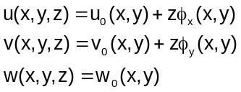

where 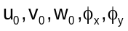 represent the three mid plane displacements and two functions, 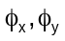, related to the rotations of a normal to the mid-plane. If 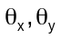are rotations of the normals to the mid-plane about the x and y axes respectively (positive with a right hand rule):

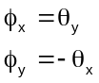

If the plate is thin enough, the Kirchoff hypothesis (normals to the mid-plane before deformation remain normal to the mid-plane after deformation) can be invoked in which case:

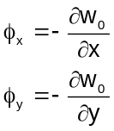

Since w is not a function of z, the normal strain in the z direction is identically zero leaving only the normal strains in the x and y directions as well as the three shear strains.

For problems in which strains are small but rotations are not, the following Greens strain terms in equation 2.1.1 can be assumed to be negligible for plate elements:

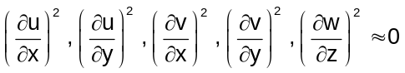

However, the following terms are retained in order to allow representation of large rotations:

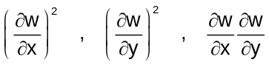

With these assumptions, the form of the nonlinear strains to be used for plate elements is (note we change notation for strains from 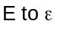and to emphasize that these are not full nonlinear Greens strains):

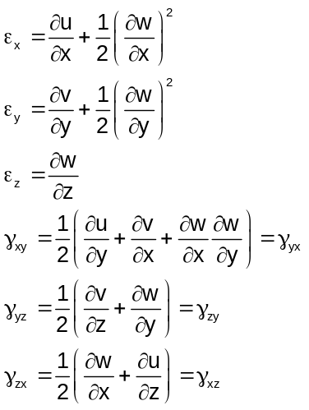

Substitute 3.1.1 into 3.1.6 to obtain the plate strains (known as von Karman nonlinear strains):

The superscript 0 refers to strains at the plate mid-plane and the superscript 1 refers to the changes in strain, from the mid-plane, for points at a distance z from the mid-plane.

Equation 3.1.7 is the form of the nonlinear strains for plate elements. The incorporation of the functions 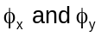 allow modeling of thin (Kirchoff) or moderately thick (Mindlin) plates. For thin plates are constrained to be as shown in equation 3.1.3. Note that in this case (thin plates only) that the two transverse shear strains 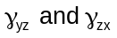 are zero leaving only three nonzero strains (the two normal strains and the in-plane shear strain).

Preload stiffness

The matrix relates the nonlinear portion of the changes in strain to element changes in nodal displacements, . From equation 3.1.7 the nonlinear portion of the plate element strain is:

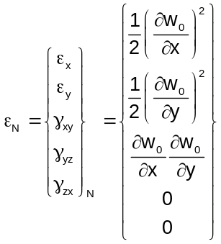

As shown in section 2 this can be written as

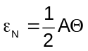

Comparing equations 3.2.1 and 3.2.2 it can be seen that for the plate element:

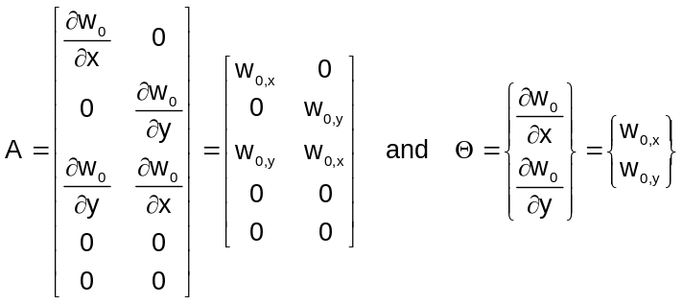

where the comma on the w₀ terms indicates partial differentiation with respect to x or y. The displacement w₀ is assumed to be a polynomial in x and y with node displacements and rotations as coefficients. That is, we approximate:

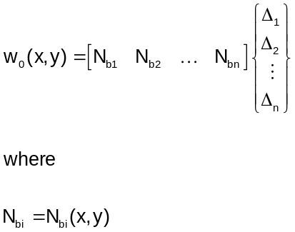

The N_{bi} are shape functions and the _{I} are the components of the nodal displacements and rotations. There are n degrees of freedom per element (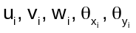at each element node. The N_{bi} are chosen in terms of element parametric coordinates and differ from element type to element type (see, for example, references 3 and 4). Their selection has been the topic of many scientific papers over many years. We won’t pick them at this time as we are just developing the form of the stiffnass matrix equations. Note that not all of the N_{bi} are nonzero as w₀ does not depend on all of the nodal values in .

The matrix is made up of derivatives of w₀ and can be written using equations 3.2.3 and 3.2.4 as:

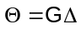

where

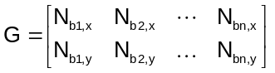

In section 2 it was shown that

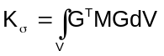

For a plate element the M matrix in section 2 is:

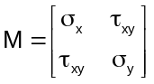

Using equation 3.2.6 and 3.2.8 in 3.2.7 the plate preload stiffness matrix is:

The shape functions in equation 3.2.9 are expressed in terms of element parametric coordinates and cannot readily be transformed to physical coordinates in closed form. Typically, the stiffness matrices are obtained by Gaussian integration. The shape functions used in equation 3.2.9 differ for each element type (triangle and quad, Kirchoff and Mindlin)

The stresses are updated each load step (or even each iteration in one load step) to allow calculation of . The nonlinear strain-displacement matrix, B_{N} is needed for several other stiffness terms in equation 2.2.5. From equations 2.2.12, 3.2.3 and 3.2.6:

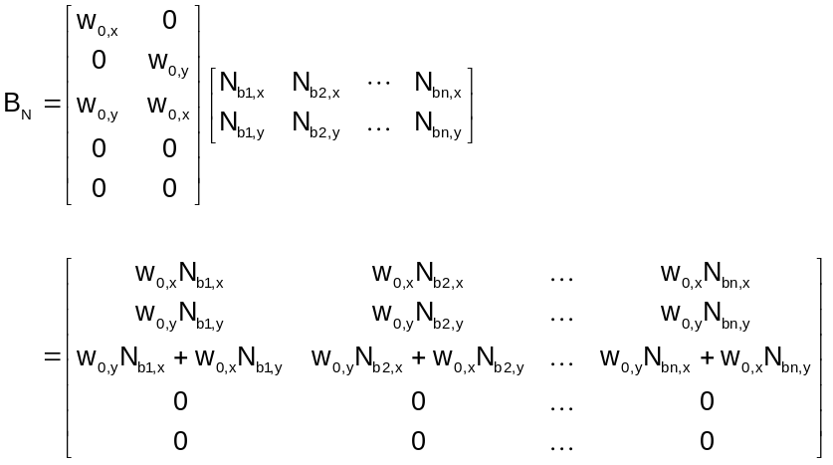

The derivatives of w₀ in equation 3.2.10 are determined from derivatives of equation 3.2.4 and using the element node displacements in the vector . These matrices have to be recalculated in each load step (or maybe for each iteration in a load step) and differ for each element type. Based on the B_{N} nonlinear strain-displacement matrix calculated above, stress recovery matrices also have to be updated.

Planar beam equations

Displacements and strains

For a beam lying along the x axis and bending in the x-y and x-z planes the displacements are

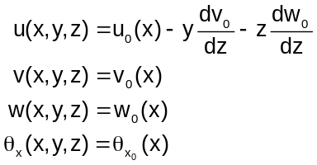

where u, v and w are the displacements in the x (axial), y and z (lateral directions) respectively and the subscript 0 refers to displacements along the center line of the beam

The only nonzero strains are the normal strain in the x direction and the torsional shear strain. Allowing for finite rotations and ignoring other terms in the Greens strain tensor, these strains are:

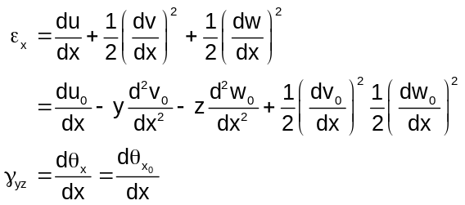

The first three terms in 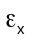 constitute the linear portion of the strain and the last 2 terms are the nonlinear portion of the strain. The torsional shear strain is linear since all of the nonlinear terms in the Greens strain are zero as a result of the assumption that the displacements, for a beam, are only a function of x.

The nodal displacements of the beam consist of the axial and lateral displacements and bending rotations at the 2 ends:

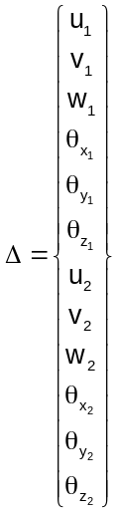

The rotational degrees of freedom,, are positive about the x, y and z axes according to a right hand rule,

The displacements in equation 4.1.1 can be written in terms of the nodal values in 4.1.3 as:

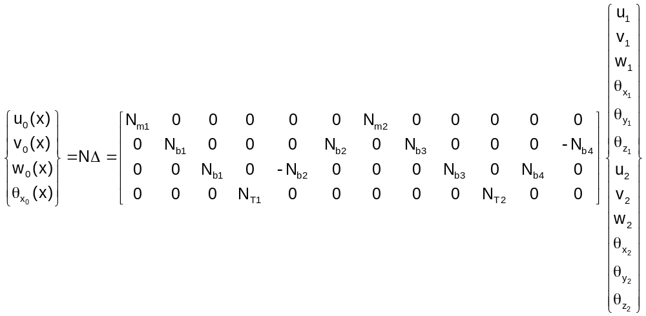

where the N’s are shape functions with N_{mi} being functions for axial displacements and N_{bi} functions for lateral displacement. For a planar beam element whose centroidal axis coincides with the neutral axis:

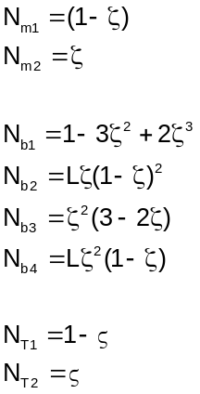

where

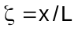

Linear stiffness matrix

The linear stiffness matrix was shown in section 2 to be:

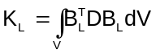

Matrix B_{L} relates the element displacements to linear strains. The linear portion of the strain in equation 4.1.2 is

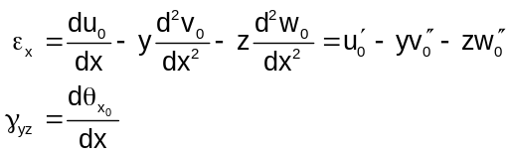

where the prime indicates differentiation with respect to x. Using equation 4.1.4 this is:

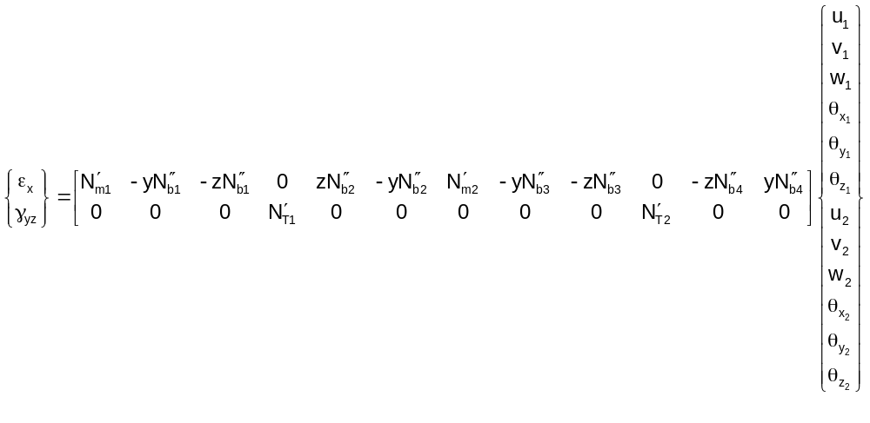

This will be written as:
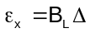

Where B_{L} is the strain-displacement matrix and is the coefficient matrix in equation 4.2.3

In equation 4.2.1 the constitutive equation consists of only the 2 terms E (Young’s modulus) and G_{s} (shear modulus):

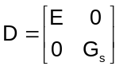

For a beam whose neutral axis is along its centerline the terms proportional to z integrate to zero so that K_{L} is:

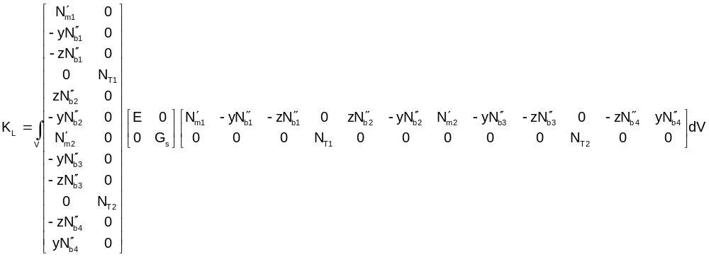

Multiplying the matrices:
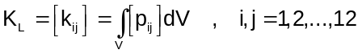

The details of the integration of each of the terms in equation 4.2.5 are shown in Appendix A. The result is shown on the next page:

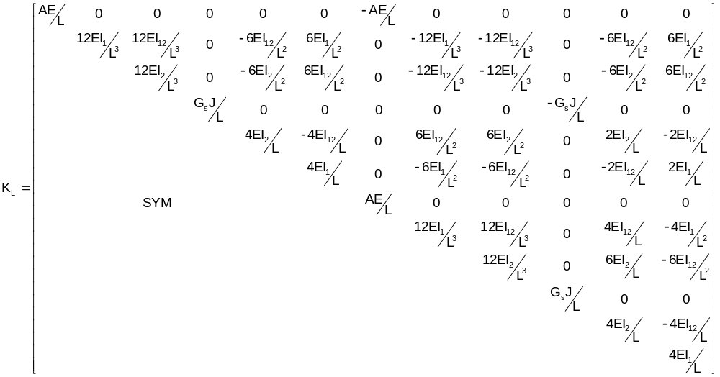

Nonlinear Preload stiffness

From equation 4.1.2 the nonlinear portion of the element strain is:

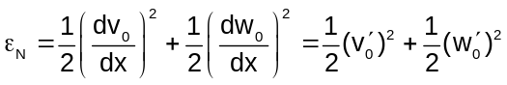

As was done in section 2 this will be written as

where, for this beam element

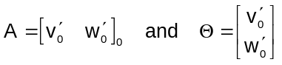

The displacements v₀ and w₀ are determined from equations 4.1.4 and 4.1.5

The matrix in equation 4.3.3 can be written using the 2nd and 3rd rows of equation 4.1.4 as:

where

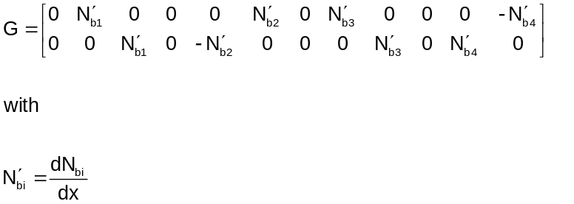

In section 2 it was shown that the preload stiffness is:

For a planar beam the M matrix (see section 2) is 2x2 with values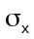on the diagonal. Using this and equation 4.2.6 for G we get the preload stiffness as:

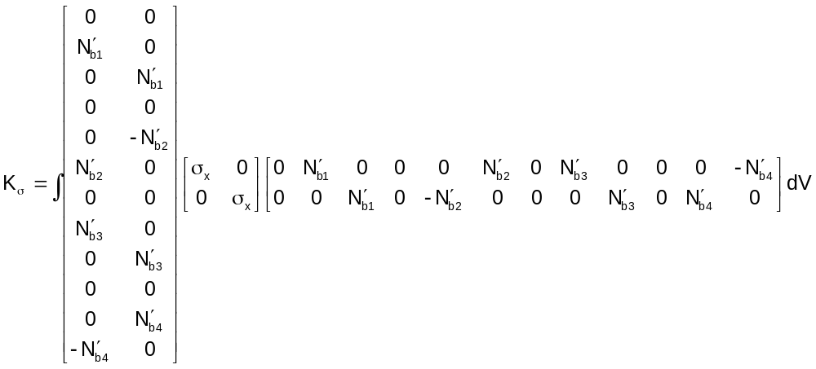

This integral can be written as integrating over the beam area and integrating the shape functions over the length. For linear over the cross-section, the integral of over the area is simply the average stress. So that equation 4.3.7 can be written as:
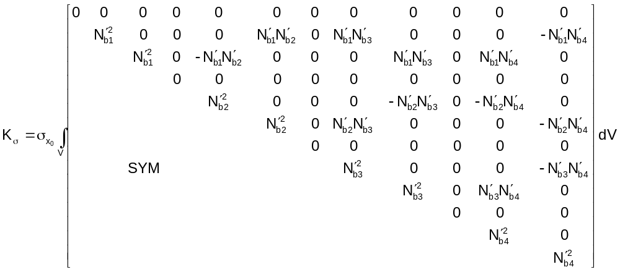

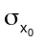is the average x direct stress over the cross-section. Note that the beam axial load, P, is:

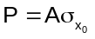

The details of the integration of each of the terms in equation 4.3.8 is shown in Appendix A. The result is:

The stresses are updated each load step (or even each iteration in one load step) to allow calculation of . The nonlinear strain-displacement matrix, B_{N} is needed for several other stiffness terms in equation 2.2.5. From equations 2.2.12, 4.3.4 and 4.3.5:

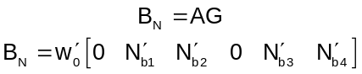

Nonlinear large rotation stiffness- need to change to 12x12 (is now 6x6)

The nonlinear large rotation stiffness matrix was shown in section 2 to be:

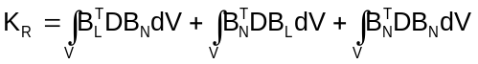

From equations 4.2.3 and 4.3.11

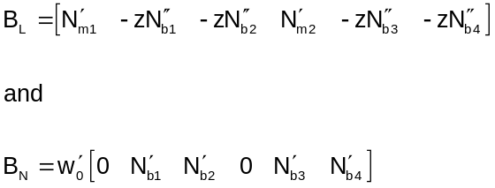

The N’s and their derivatives in equation 4.4.2 are “linear”; that is they are not functions of the displacements. However, 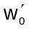 is the element rotation about the y axis and must be updated during the load step process. Due to the symmetry of the constitutive matrix, D, equation 4.4.1 can be written as:

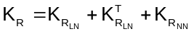

where

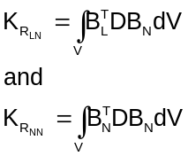

These two contributions will be evaluated below. From equation 4.4.2 and the fact that D is a 1x1 matrix with Young’s modulus:

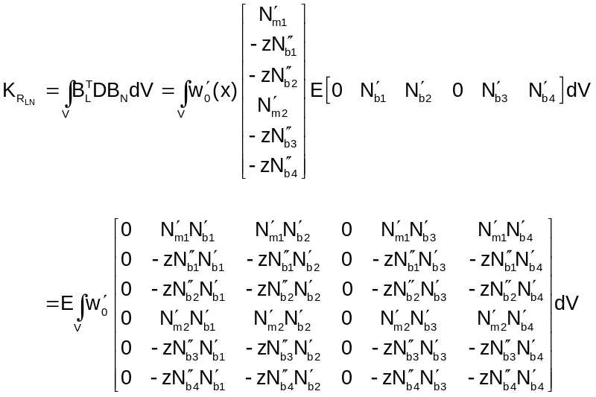

For a beam whose neutral axis coincides with its centroidal axis, the terms proportional to z will integrate to zero. Thus, for this situation (D is the 1x1 matrix with Young’s modulus E):

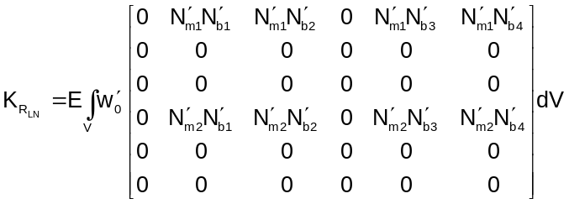

Then the first two parts of K_{R} in equation 4.4.3 are:

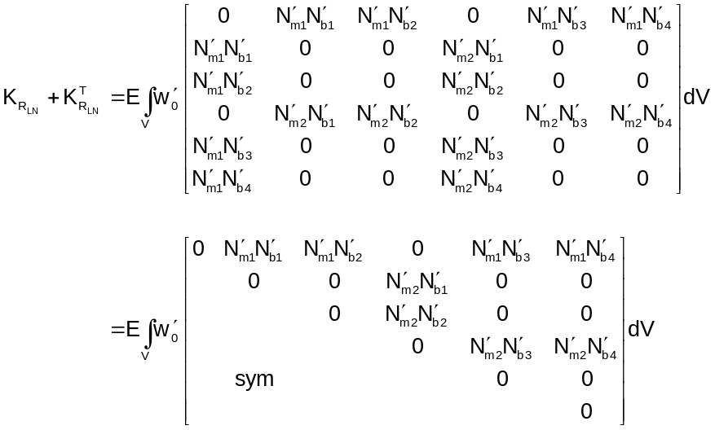

w₀ and the N’s are given in equations 4.1.4 and 4.1.5 so equation 4.4.8 can be written as:

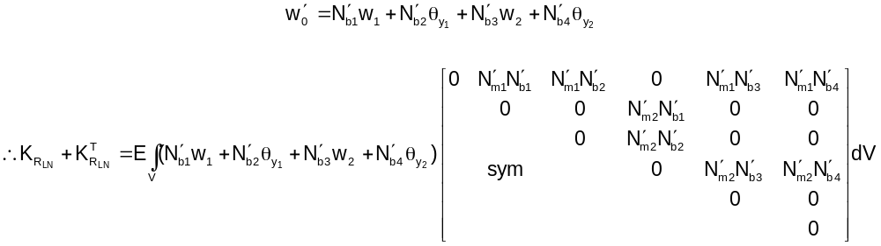

where 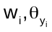are the displacements and rotations of the beam at nodes i=1,2. The details of the integration of each of the terms in equation 4.4.9 are shown in Appendix A. The result is:

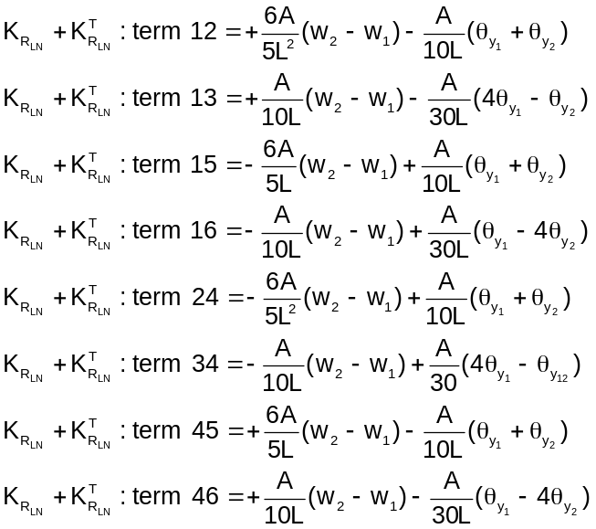

Notice that if the element displacements and rotations are rigid body that:

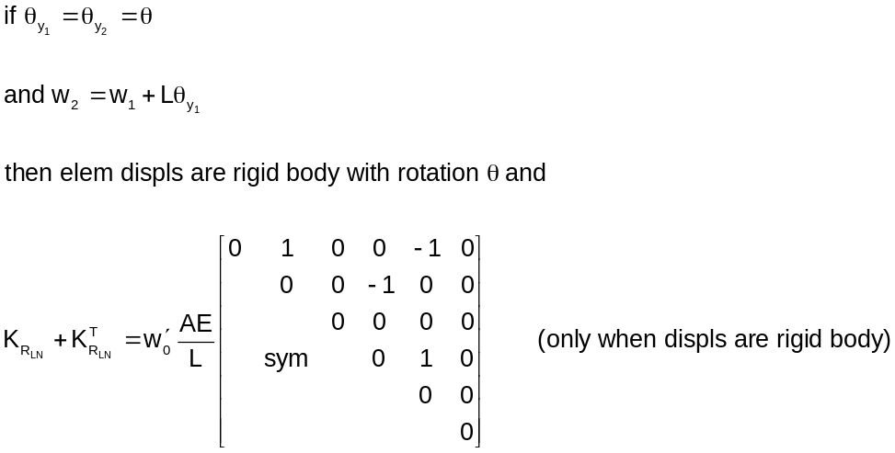

The 2nd portion of K_{R} in equation 4.4.4 is evaluated using equation 4.4.2 for B_{N} to get:

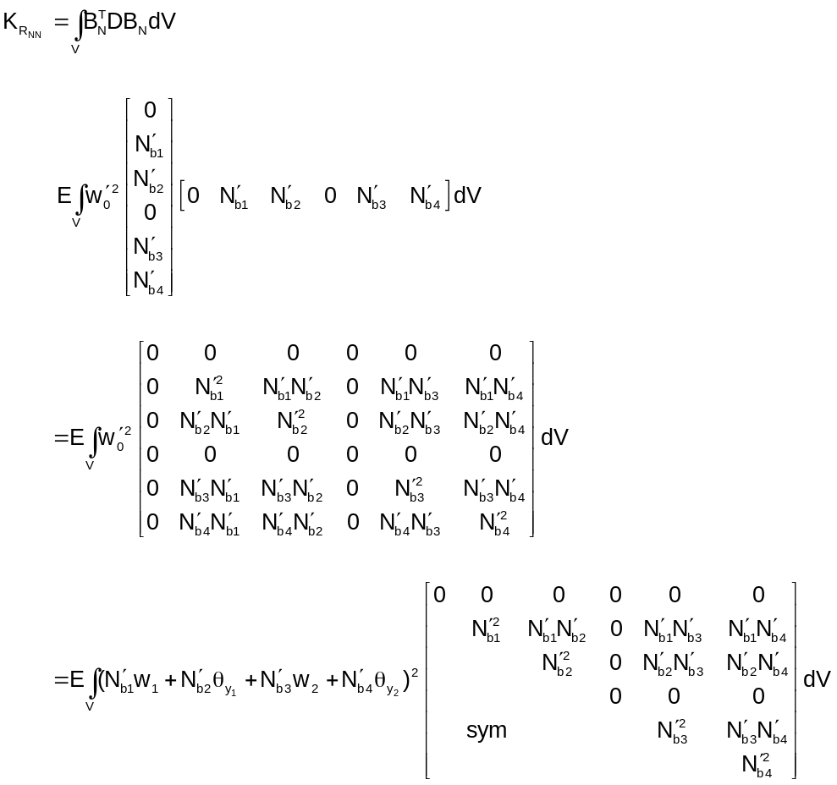

The terms in equation 4.4.12 are evaluated in Appendix A. Using equation 4.1.4 for the 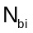the result for the terms in equation 4.4.12 is:

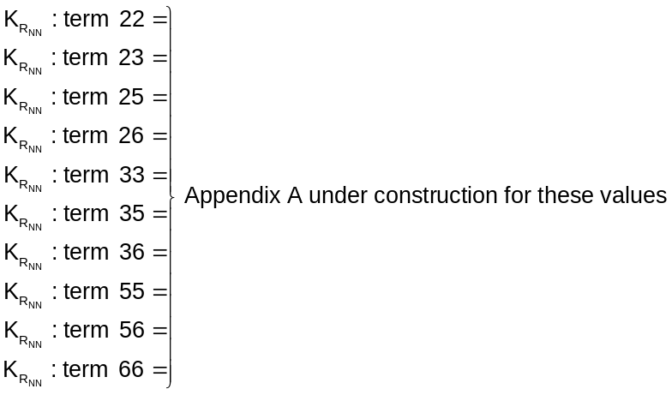

Equations 4.4.9 (with terms defined in equation 4.4.10) and 4.4.13 are substituted into 4.4.3 to get the final form for the nonlinear large rotation stiffness. The 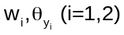 displacements and rotations at the 2 nodes in those equations are the nonlinear terms. During the process of stepping the applied loads and determining the increments of displacement these terms are determined These are then used in K_{R} to get the next tangent matrix contribution for nonlinear large rotation.

Total stiffness matrix

The total tangent stiffness matrix for the planar beam, as shown in section 2, is the sum of the linear stiffness (K_{L} , equation 4.2.6) the nonlinear large rotation matrix (K_{R ,} equations 4.4.9 and 4.4.12) and the preload matrix ( , equation 4.3.10).

References
- “An introduction to nonlinear finite element analyses”, J. N. Reddy, Oxford University Press, 2004
- “MSC/NASTRAN Handbook for nonlinear analyses, version 67”, Sang H. Lee, MSC Corporation, 1992
- “Finite element analysis: fundamentals”, R. H. Gallagher, Prentice Hall, 1975
- “The finite element method”, O. C. Zienkiewicz and R. L. Taylor, McGraw Hill. 4th edition, 1989

Appendix A: Integration of integrals in stiffness equations

Integrals for planar beam stiffness equations in section 4

The following 3 sections are detailed derivations of the integrals appearing in the 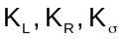 stiffness equations for the planar beam

Integrals for the planar beam linear stiffness, K_{L} , in equation 4.2.5

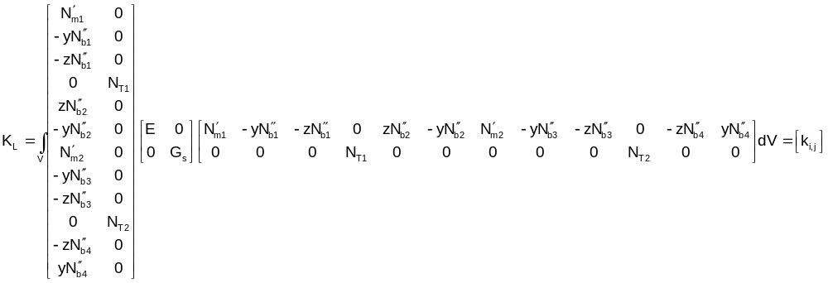

with I,j = 1,…,12. Note that the integrals involving linear terms in y and z are zero so that:

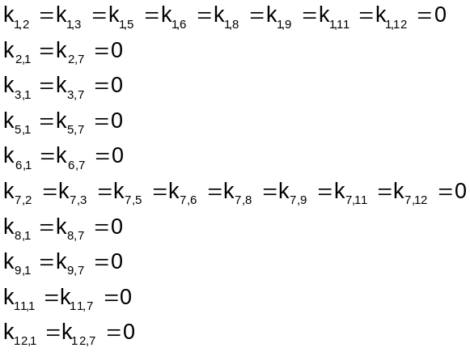

term 1,1
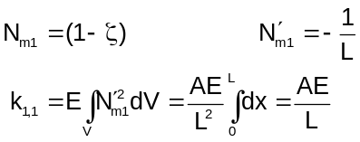

term 1,7
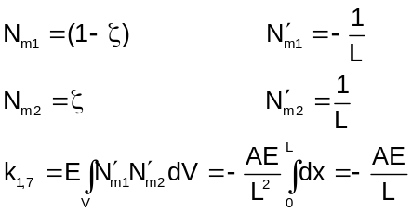

term 2,2

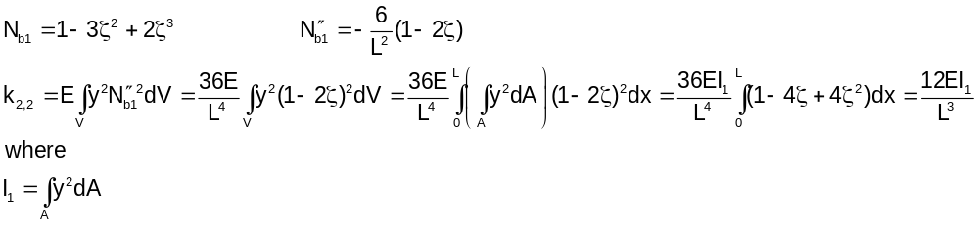

term 2,3

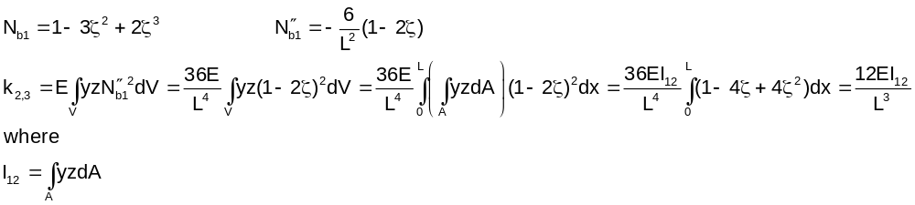

term 2,5

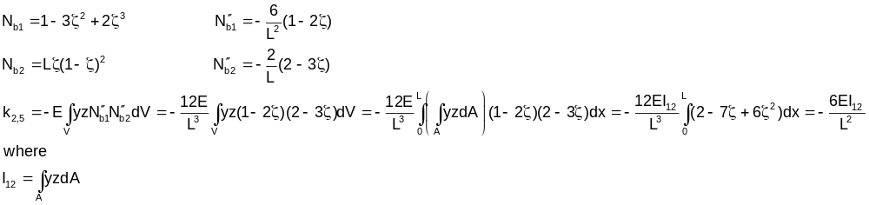

term 2,6

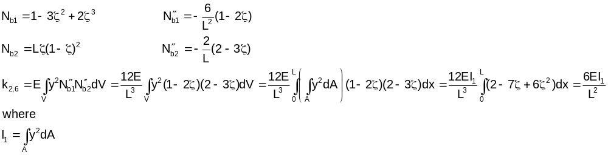

term 2,8

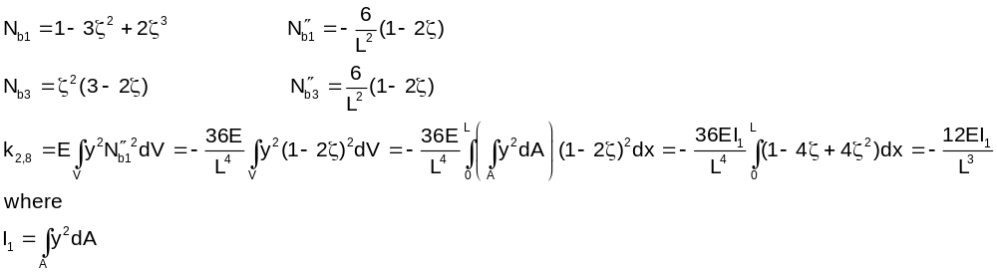
term 2,9

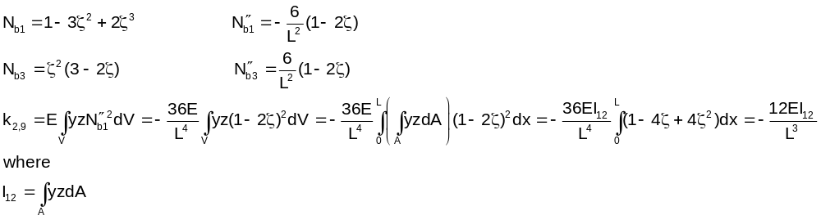

term 2,11

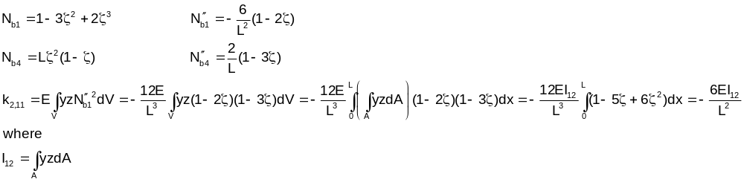

term 2,12
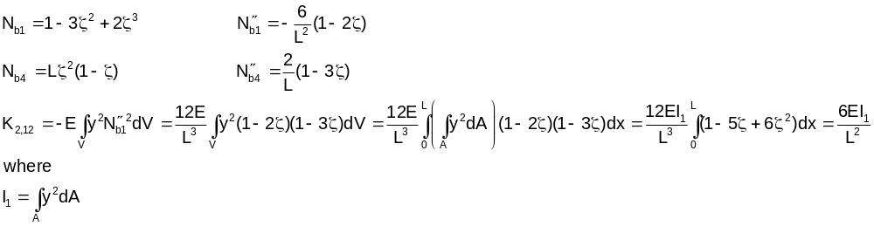

term 3,3

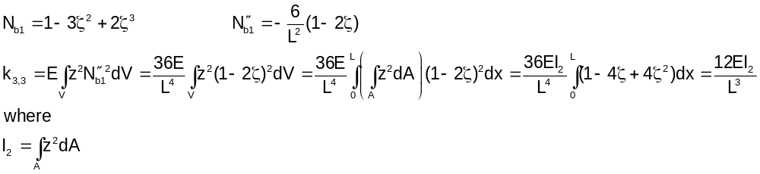

term 3,5
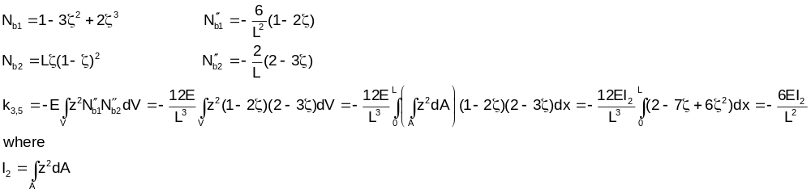

term 3,6
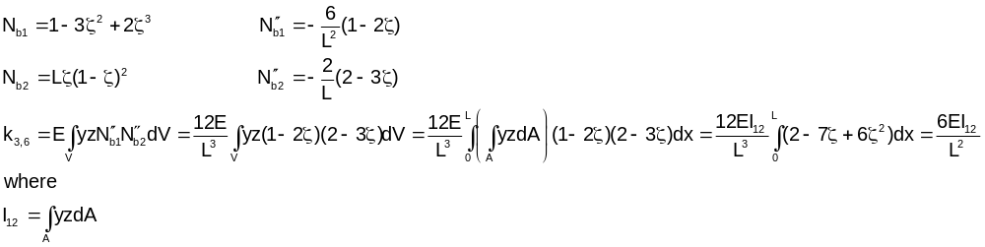
term 3,8
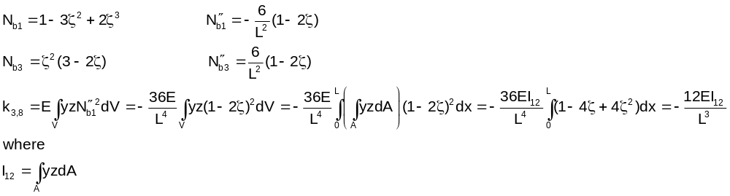

term 3,9

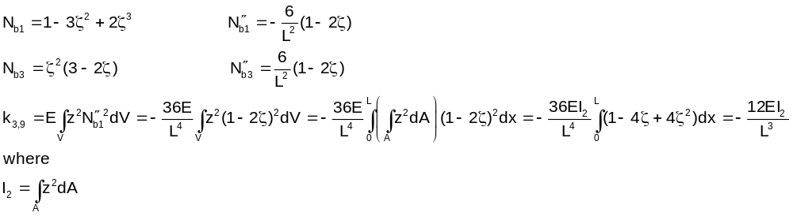

term 3,11
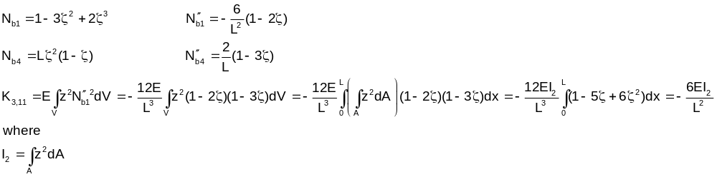

term 3,12 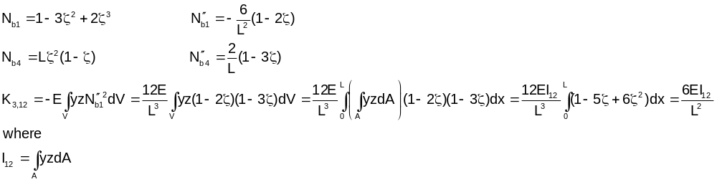

term 4,4
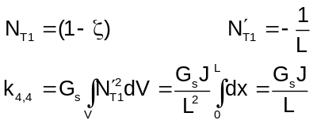

term 4,10
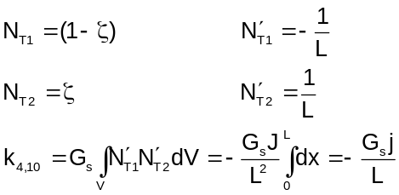

term 5,5

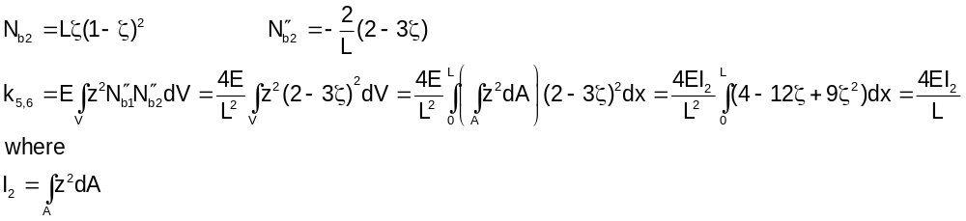

term 5,6

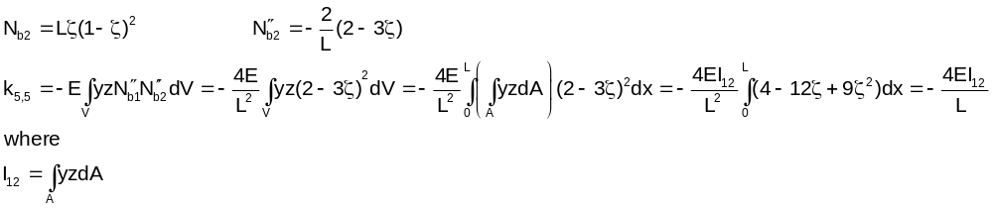

term 5,8
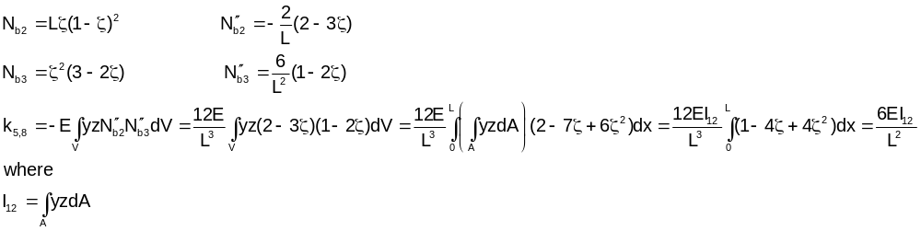
term 5,9

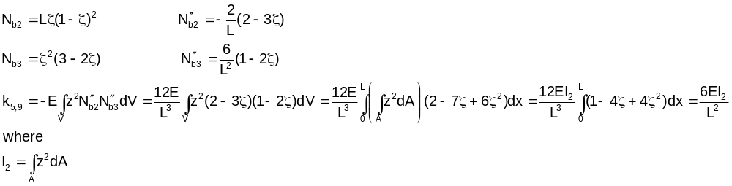
term 5,11

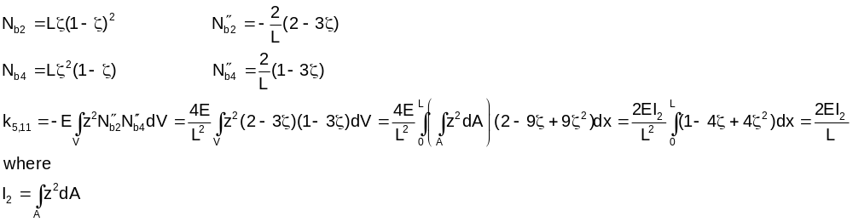
term 5,12
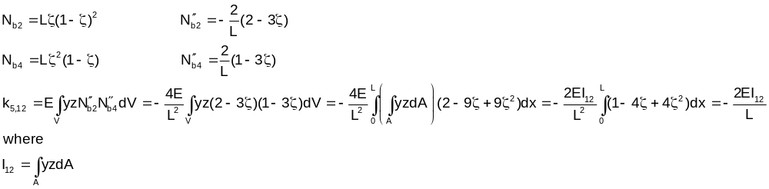
term 6,6

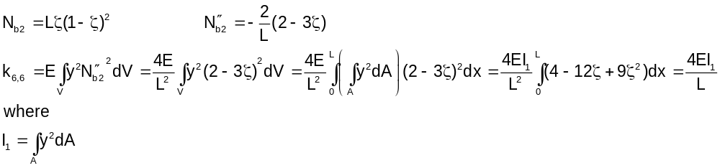
term 6,8 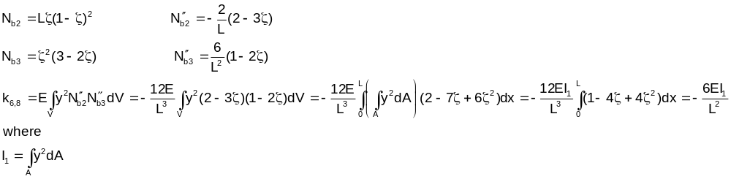
term 6,9
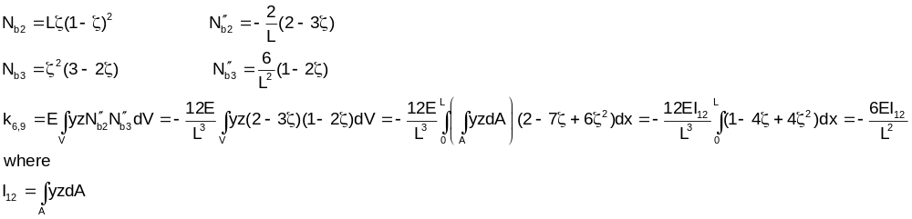
term 6,11
term 6,12
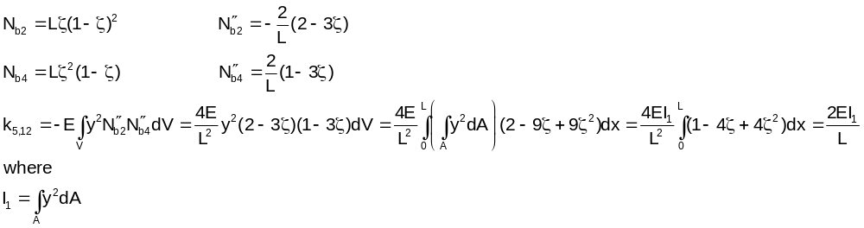

term 7,7
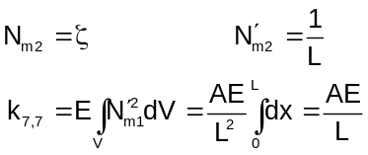

term 8,8

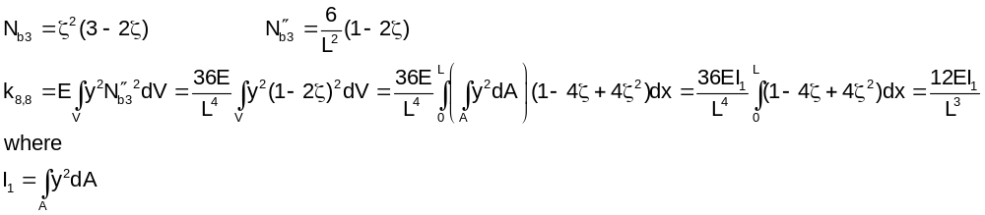

term 8,9

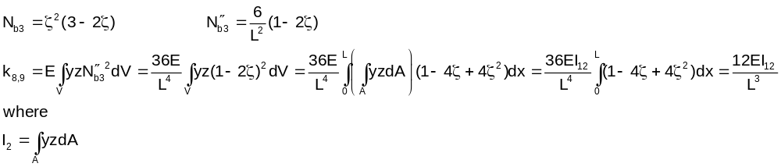
term 8,11
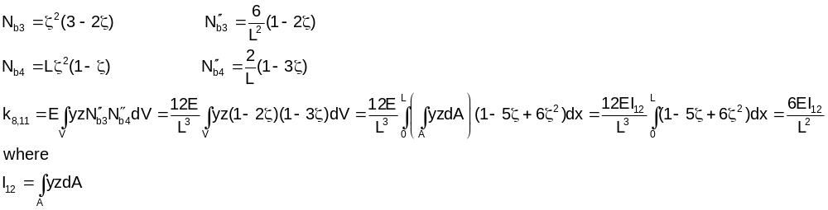
term 8,12 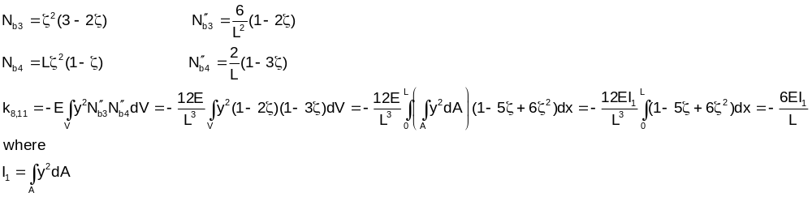
term 9,9

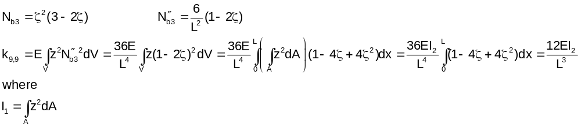

term 9,11
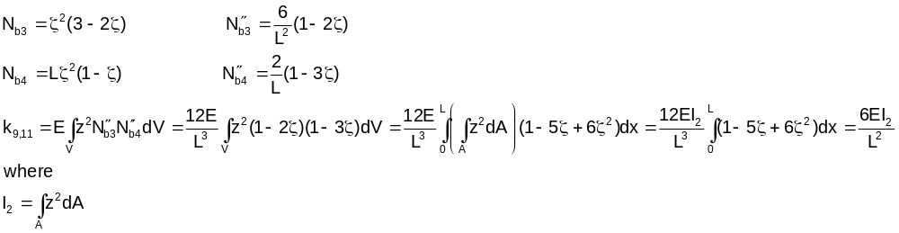
term 9,12
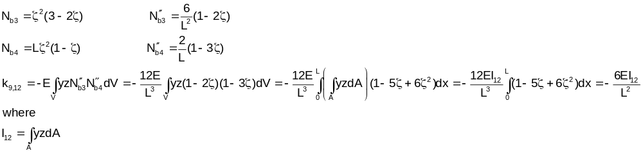
term 10,10
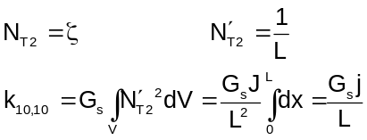

term 11,11
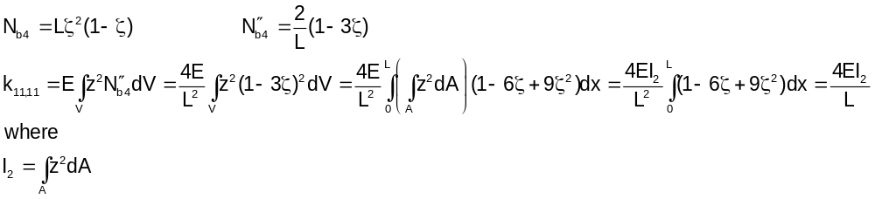

term 11,12
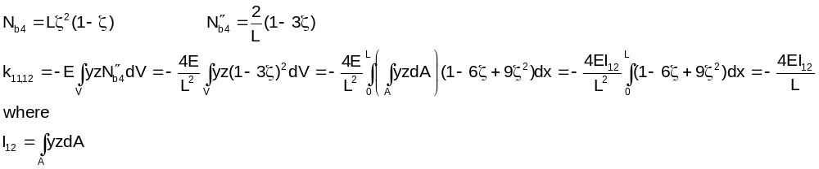

term 12,12

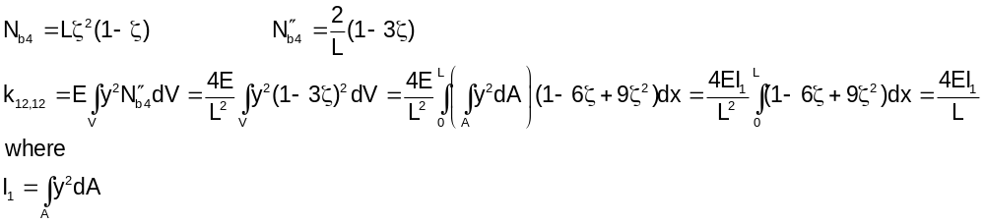

Integrals for the planar beam preload stiffness, , in equation 4.3.8
:

terms 2,2 and 3,3
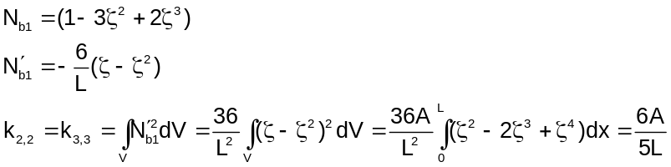

terms 2,6 and 3.5

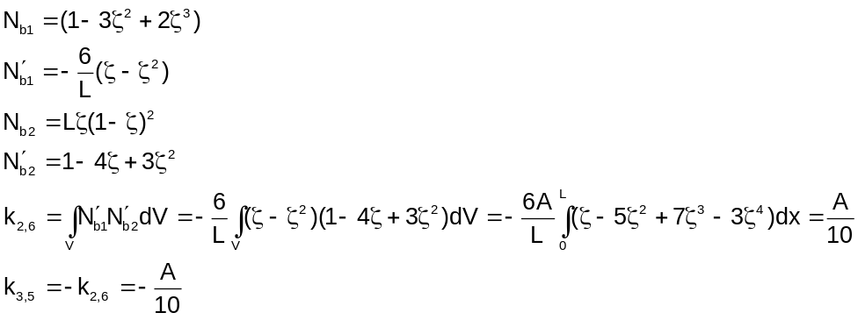

terms 2,8 and 3,9

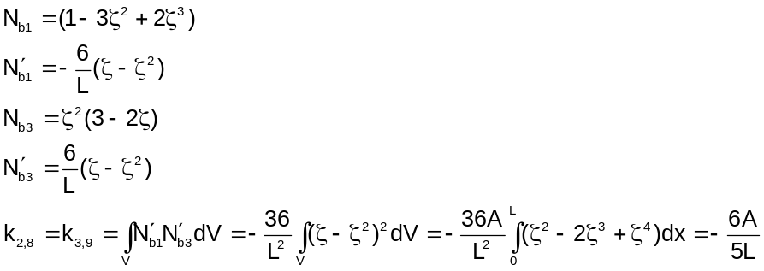

terms 3,11 and 2,12

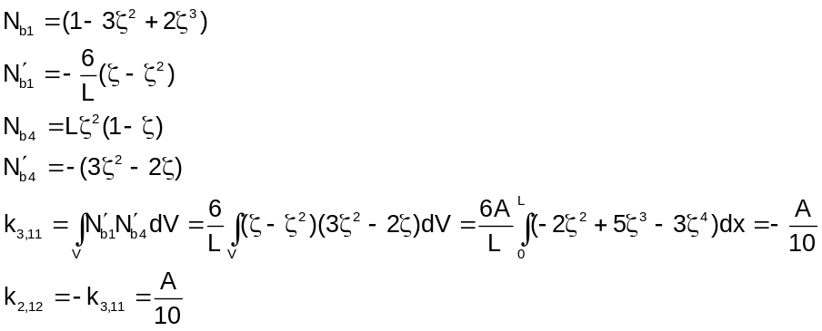

terms 5,5 and 6,6

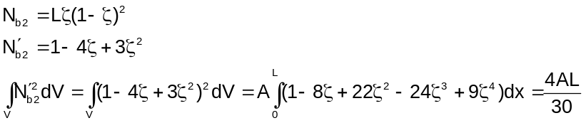

terms 6,8 and 5,9

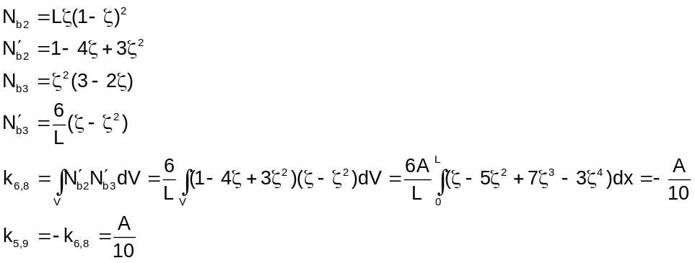

terms 6,12 and 5,11

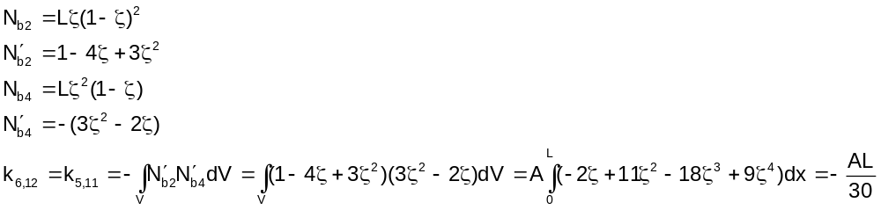

terms 8,8 and 9,9
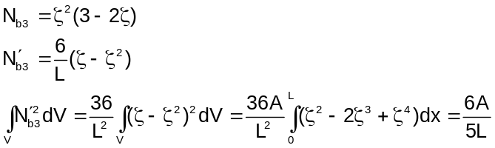

terms 9,11 and 8,12

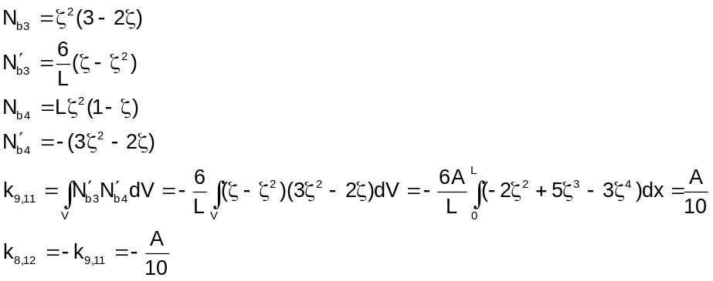

Terms 11,11 and 12,12

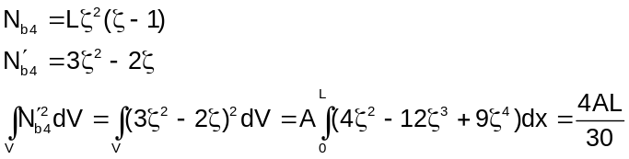

Integrals for the planar beam nonlinear large rotation stiffness, K_{R}

The following will be needed for calculation of the terms in equation 4.4.9:

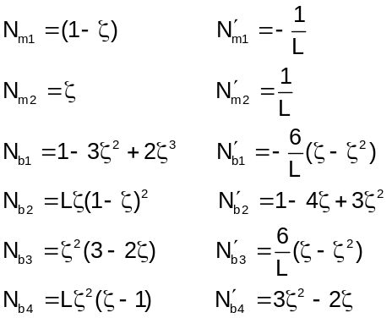

term 12
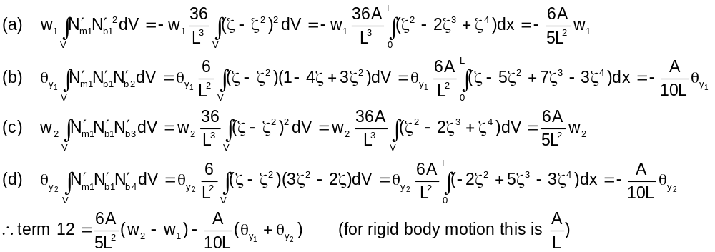

term 13
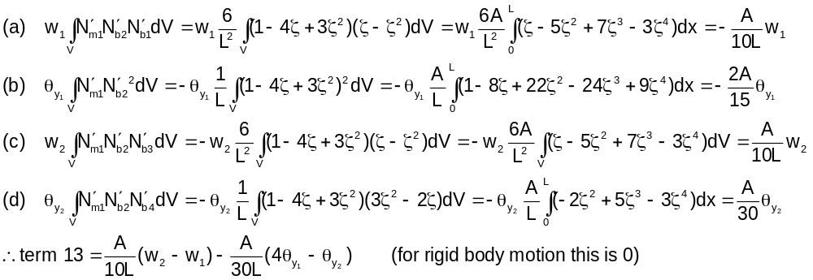

term 15
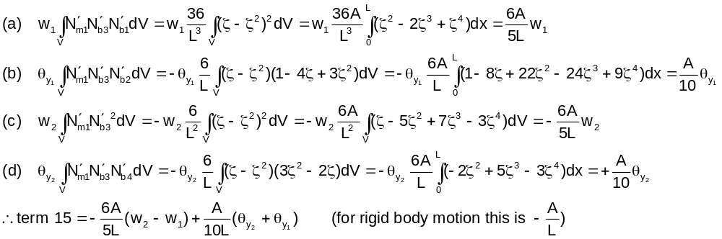

term 16
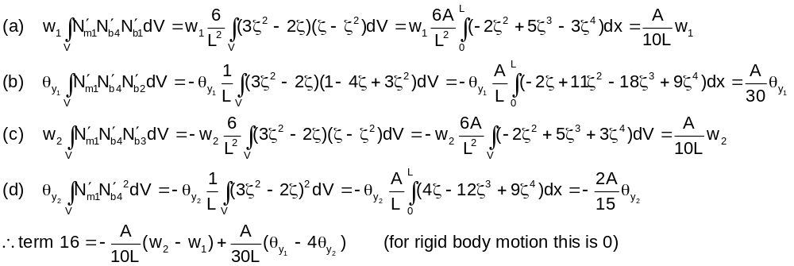

term 24
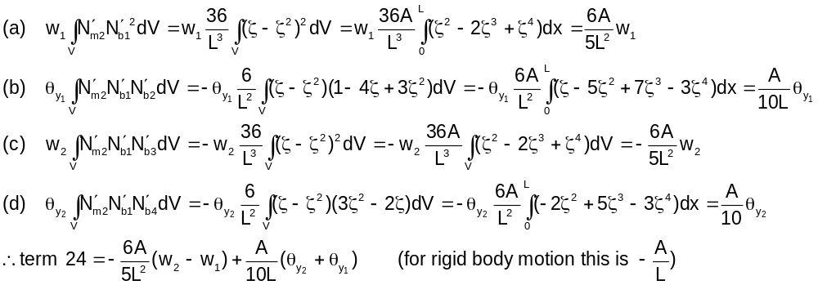

term 34
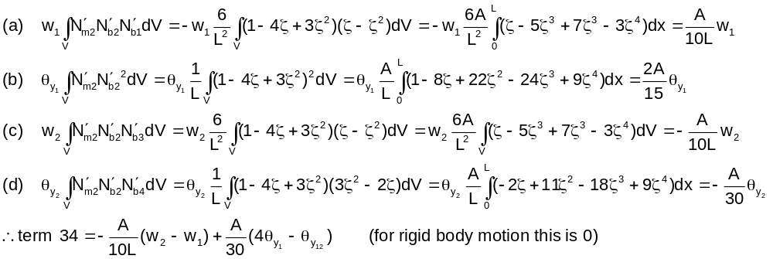

term 45
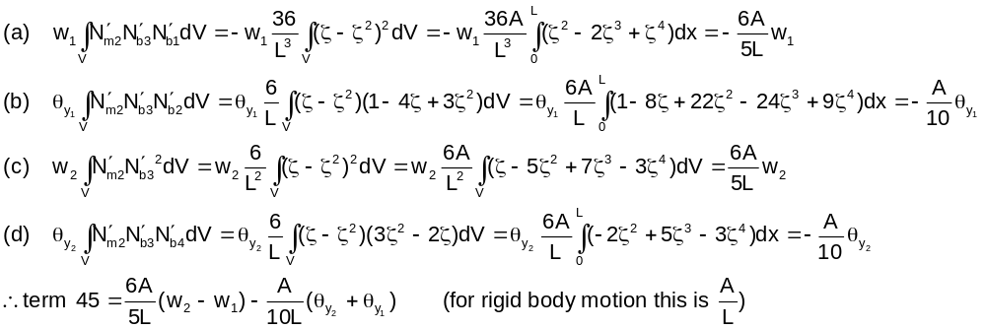

term 46
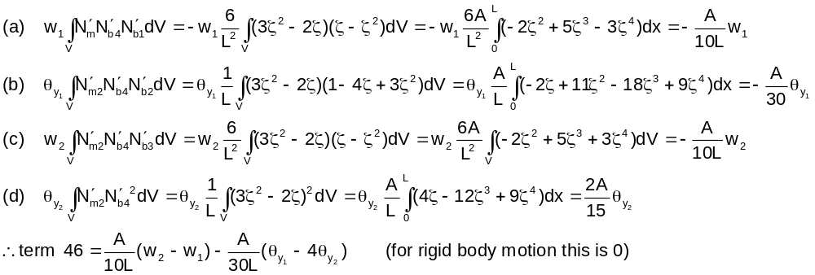

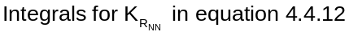

(this section of Appendix A under construction)

